**Microsoft Power Platform**

**Training Program Entrance Test**

This test has 3 tasks. Please finish all of it and change the name of this document into “your Chinese name +your english name +your school + entrance test”(例：张小红+ Red Zhang + 华南师范大学).

Task 1 Self-Estimating:

Below are statements that describe how you may think about yourself right now. Use the following scales to indicate your level of agreement or disagreement with each statement.

(1 = Strongly disagree, 2 = disagree, 3 = somewhat disagree, 4 = somewhat agree, 5 = agree, 6 = strongly agree)

|  |  |
| --- | --- |
| **Question** | **Score**  **(1 - 6)** |
| 1. I feel confident analyzing a long-term problem to find a solution. | 3 |
| 2. I feel confident in representing my work area in meetings with management. | 3 |
| 3. I feel confident contributing to discussions about the company’s strategy. | 3 |
| 4. I feel confident helping to set targets/goals in my work area. | 6 |
| 5. I feel confident contacting people outside the company (e.g., suppliers, customers) to discuss problems. | 3 |
| 6. I feel confident presenting information to a group of colleagues. | 3 |
| 7. If I should find myself in a jam at work, I could think of many ways to get out of it. | 4 |
| 8. At the present time, I am energetically pursuing my work goals. | 6 |
| 9. There are lots of ways around any problem. | 5 |
| 10. Right now I see myself as being pretty successful at work. | 3 |
| 11. I can think of many ways to reach my current work goals. | 4 |
| 12. At this time, I am meeting the work goals that I have set for myself. | 5 |
| 13. When I have a setback at work, I have trouble recovering from it, moving on. | 2 |
| 14. I usually manage difficulties one way or another at work. | 3 |
| 15. I can be “on my own,” so to speak, at work if I have to. | 4 |
| 16. I usually take stressful things at work in stride. | 3 |
| 17. I can get through difficult times at work because I’ve experienced difficulty before. | 3 |
| 18. I feel I can handle many things at a time at this job. | 3 |
| 19. When things are uncertain for me at work, I usually expect the best. | 3 |
| 20. If something can go wrong for me work-wise, it will. | 2 |
| 21. I always look on the bright side of things regarding my job. | 3 |
| 22. I’m optimistic about what will happen to me in the future as it pertains to work. | 3 |
| 23. In this job, things never work out the way I want them to. | 3 |
| 24. I approach this job as if “every cloud has a silver lining.” | 3 |

Task 2 Programing Skill：

编程作业从开发工具中导出以Git为后缀的repo，做完是这篇文档+repo一个压缩包的形式发到邮箱中。

请根据mock up内附件，制作 H5 webpage, 要求使用Vue 和Ant Design of Vue实现；

只需要完成下面流程的UI Mock和交互，没提到的功能都不需要做；

需要屏幕自适应，最小适配375px屏幕大小；

图标只需要用开源的字体图标库即可，不用完全按mock up，配图可以在mock up上切图。

主题流程

* 从Login page (Mockup/ login page.png)点login按钮进去Inspection Form A (Mockup/ floor plan.jpg);
* Inspection Form A 右上角飞机图标保持0.8透明度而且不可点击， 点save only 则让当前表单变成read only, 点mark as completed则跳到Floor Plan page (Mockup/ floor plan.jpg);

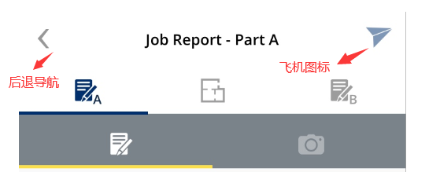

* Floor Plan页需要保持右上角飞机图标0.8透明度而且不可点击， 可以通过回退按钮或者顶部sup tab切到Form A，但不能到Form B。需要点击mark inspection Spot按钮才能 跳转到Form B，并需要把对应Floor plan Name 带去Form B (Mockup/ Inspection Form B.png);



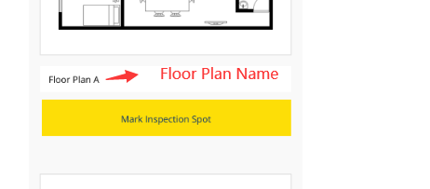

* 进去Form B需要把Floor plan Name显示在指定处，此时飞机图标变成1透明度并可以点击，点击之后出现Submiting (Mockup/ Inspection Form - Submiting.jpg);遮罩并在3秒后消失。

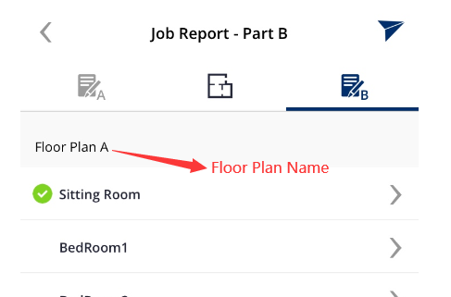

Task 3 English Translation：

Please translate the following sentences into English

1. 经过对比，以下是我的建议。

After comparison, here are my suggestions.

1. 还有人有其它看法吗？请提出来。

Does anyone else have any other views? Please bring it up.

1. 这个培训的重点是为了对公司有一个大致的了解。

The focus of this training is to have a general understanding of the company.

1. 这不是最有效率的方法。

This is not the most efficient method.

1. 我对运作的流程还不熟悉。

I am not familiar with the operation process.

1. 你可以再核对一下数据吗？

Can you check the data again?

1. 这个项目的进展怎么样？

How is the project going?

Please write an English self-introduction of not less than 50 words

I’m Li RuiYuan,21 years old.I’m a quiet boy,but I like singing.I come from GuangDong ShanTou.Now I wish to get a job in front end development. I’m familiar with HTML ,CSS ,JavaScript and so on.Finally , I’m looking forward to join in company.Thank you!

—This is the end of the task. Thank you for your time.—